**EXPLORING SPRING FRAMEWORK WITH JAVA - SECTION 1 – REVIEW**

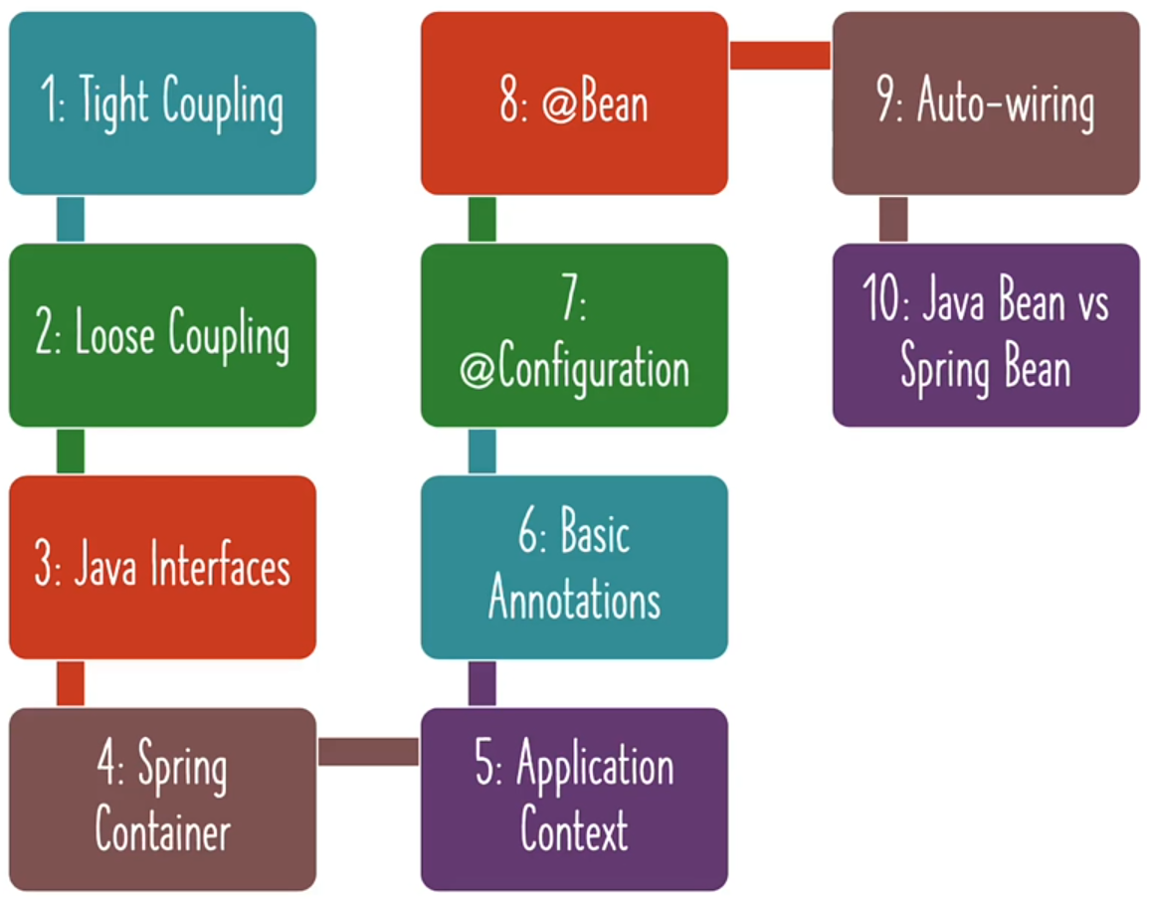

These are the concepts we have learnt now. Still haven’t answer some questions.

1. **Spring is managing objects and performing auto-wiring.** 
   1. But aren't we writing the code to create objects?
   2. How do we get Spring to create objects for us?
2. **Is Spring really making things easy?**